**Choosing the Right Statistical Test | Types & Examples**

**Statistical tests** are used in [hypothesis testing](https://www.scribbr.com/statistics/hypothesis-testing/). They can be used to:

* determine whether a predictor variable has a statistically significant relationship with an outcome variable.
* estimate the difference between two or more groups.

Statistical tests assume a [null hypothesis](https://www.scribbr.com/statistics/null-and-alternative-hypotheses/) of no relationship or no difference between groups. Then they determine whether the observed data fall outside of the range of values predicted by the null hypothesis.

**What does a statistical test do?**

Statistical tests work by calculating a [**test statistic**](https://www.scribbr.com/statistics/test-statistic/)– a number that describes how much the relationship between variables in your test differs from the null hypothesis of no relationship.

It then calculates a [***p*-value**](https://www.scribbr.com/statistics/p-value/) (probability value). The *p*-value estimates how likely it is that you would see the difference described by the test statistic if the null hypothesis of no relationship were true.

If the value of the test statistic is more extreme than the statistic calculated from the null hypothesis, then you can infer a **statistically significant relationship** between the predictor and outcome variables.

If the value of the test statistic is less extreme than the one calculated from the null hypothesis, then you can infer **no statistically significant relationship** between the predictor and outcome variables.

**When to perform a statistical test**

You can perform statistical tests on data that have been collected in a statistically valid manner – either through an [experiment](https://www.scribbr.com/frequently-asked-questions/what-is-experimental-design/), or through observations made using [probability sampling methods](https://www.scribbr.com/methodology/probability-sampling/).

For a statistical test to be [valid](https://www.scribbr.com/methodology/internal-vs-external-validity/), your sample size needs to be large enough to approximate the true distribution of the population being studied.

To determine which statistical test to use, you need to know:

* whether your data meets certain assumptions.
* the [types of variables](https://www.scribbr.com/methodology/types-of-variables/) that you’re dealing with.

**Statistical assumptions**

Statistical tests make some common assumptions about the data they are testing:

1. **Independence of observations** (a.k.a. no autocorrelation): The observations/variables you include in your test are not related (for example, multiple measurements of a single test subject are not independent, while measurements of multiple different test subjects are independent).
2. **Homogeneity of variance**: the [variance](https://www.scribbr.com/statistics/variance/) within each group being compared is similar among all groups. If one group has much more variation than others, it will limit the test’s effectiveness.
3. **Normality of data**: the data follows a [normal distribution](https://www.scribbr.com/statistics/normal-distribution/) (a.k.a. a bell curve). This assumption applies only to [quantitative data](https://www.scribbr.com/methodology/types-of-variables/#quantitative-vs-categorical).

If your data do not meet the assumptions of normality or homogeneity of variance, you may be able to perform a [**nonparametric statistical test**](https://www.scribbr.com/statistics/statistical-tests/#nonparametric), which allows you to make comparisons without any assumptions about the data distribution.

If your data do not meet the assumption of independence of observations, you may be able to use a test that accounts for structure in your data (repeated-measures tests or tests that include blocking variables).

**Types of variables**

The [types of variables](https://www.scribbr.com/methodology/types-of-variables/) you have usually determine what type of statistical test you can use.

**Quantitative variables** represent amounts of things (e.g. the number of trees in a forest). Types of quantitative variables include:

* **Continuous** (a.k.a ratio variables): represent measures and can usually be divided into units smaller than one (e.g. 0.75 grams).
* **Discrete** (a.k.a integer variables): represent counts and usually can’t be divided into units smaller than one (e.g. 1 tree).

**Categorical variables** represent groupings of things (e.g. the different tree species in a forest). Types of categorical variables include:

* [**Ordinal**](https://www.scribbr.com/statistics/ordinal-data/): represent data with an order (e.g. rankings).
* [**Nominal**](https://www.scribbr.com/statistics/nominal-data/): represent group names (e.g. brands or species names).
* **Binary**: represent data with a yes/no or 1/0 outcome (e.g. win or lose).

Choose the test that fits the types of predictor and outcome variables you have collected (if you are doing an [experiment](https://www.scribbr.com/methodology/experimental-design/), these are the [independent and dependent variables](https://www.scribbr.com/methodology/independent-and-dependent-variables/)). Consult the tables below to see which test best matches your variables.

[**See editing example**](https://www.scribbr.com/proofreading-editing/example/?scr_source=knowledgebase&scr_medium=in-text&scr_campaign=slider)

**Choosing a parametric test: regression, comparison, or correlation**

Parametric tests usually have stricter requirements than nonparametric tests, and are able to make stronger inferences from the data. They can only be conducted with data that adheres to the common assumptions of statistical tests.

The most common types of parametric test include regression tests, comparison tests, and correlation tests.

**Regression tests**

Regression tests look for**cause-and-effect relationships**. They can be used to estimate the effect of one or more continuous variables on another variable.

|  | **Predictor variable** | **Outcome variable** | **Research question example** |
| --- | --- | --- | --- |
| [**Simple linear regression**](https://www.scribbr.com/statistics/simple-linear-regression/) | * Continuous * 1 predictor | * Continuous * 1 outcome | What is the effect of income on longevity? |
| [**Multiple linear regression**](https://www.scribbr.com/statistics/multiple-linear-regression/) | * Continuous * 2 or more predictors | * Continuous * 1 outcome | What is the effect of income and minutes of exercise per day on longevity? |
| **Logistic regression** | * Continuous | * Binary | What is the effect of drug dosage on the survival of a test subject? |

**Comparison tests**

Comparison tests look for **differences among group means**. They can be used to test the effect of a categorical variable on the [mean value](https://www.scribbr.com/statistics/mean/) of some other characteristic.

[T-tests](https://www.scribbr.com/statistics/t-test/) are used when comparing the means of precisely two groups (e.g. the average heights of men and women). [ANOVA](https://www.scribbr.com/statistics/one-way-anova/) and MANOVA tests are used when comparing the means of more than two groups (e.g. the average heights of children, teenagers, and adults).

|  | **Predictor variable** | **Outcome variable** | **Research question example** |
| --- | --- | --- | --- |
| **Paired t-test** | * Categorical * 1 predictor | * Quantitative * groups come from the same population | What is the effect of two different test prep programs on the average exam scores for students from the same class? |
| **Independent t-test** | * Categorical * 1 predictor | * Quantitative * groups come from different populations | What is the difference in average exam scores for students from two different schools? |
| **ANOVA** | * Categorical * 1 or more predictor | * Quantitative * 1 outcome | What is the difference in average pain levels among post-surgical patients given three different painkillers? |
| **MANOVA** | * Categorical * 1 or more predictor | * Quantitative * 2 or more outcome | What is the effect of flower species on petal length, petal width, and stem length? |

**Correlation tests**

[Correlation tests](https://www.scribbr.com/statistics/correlation-coefficient/) **check whether variables are related** without hypothesizing a cause-and-effect relationship.

These can be used to test whether two variables you want to use in (for example) a multiple regression test are autocorrelated.

|  | **Variables** | **Research question example** |
| --- | --- | --- |
| **Pearson’s *r*** | * 2 continuous variables | How are latitude and temperature related? |

**Choosing a nonparametric test**

Non-parametric tests don’t make as many assumptions about the data, and are useful when one or more of the common statistical assumptions are violated. However, the inferences they make aren’t as strong as with parametric tests.

|  | **Predictor variable** | **Outcome variable** | **Use in place of…** |
| --- | --- | --- | --- |
| **Spearman’s *r*** | * Quantitative | * Quantitative | Pearson’s *r* |
| **Chi square test of independence** | * Categorical | * Categorical | Pearson’s *r* |
| **Sign test** | * Categorical | * Quantitative | One-sample *t*-test |
| **Kruskal–Wallis *H*** | * Categorical * 3 or more groups | * Quantitative | ANOVA |
| **ANOSIM** | * Categorical * 3 or more groups | * Quantitative * 2 or more outcome variables | MANOVA |
| **Wilcoxon Rank-Sum test** | * Categorical * 2 groups | * Quantitative * groups come from different populations | Independent t-test |
| **Wilcoxon Signed-rank test** | * Categorical * 2 groups | * Quantitative * groups come from the same population | Paired t-test |
|  |  |  |  |

**Flowchart: choosing a statistical test**

This flowchart helps you choose among parametric tests. For nonparametric alternatives, check the table above.

[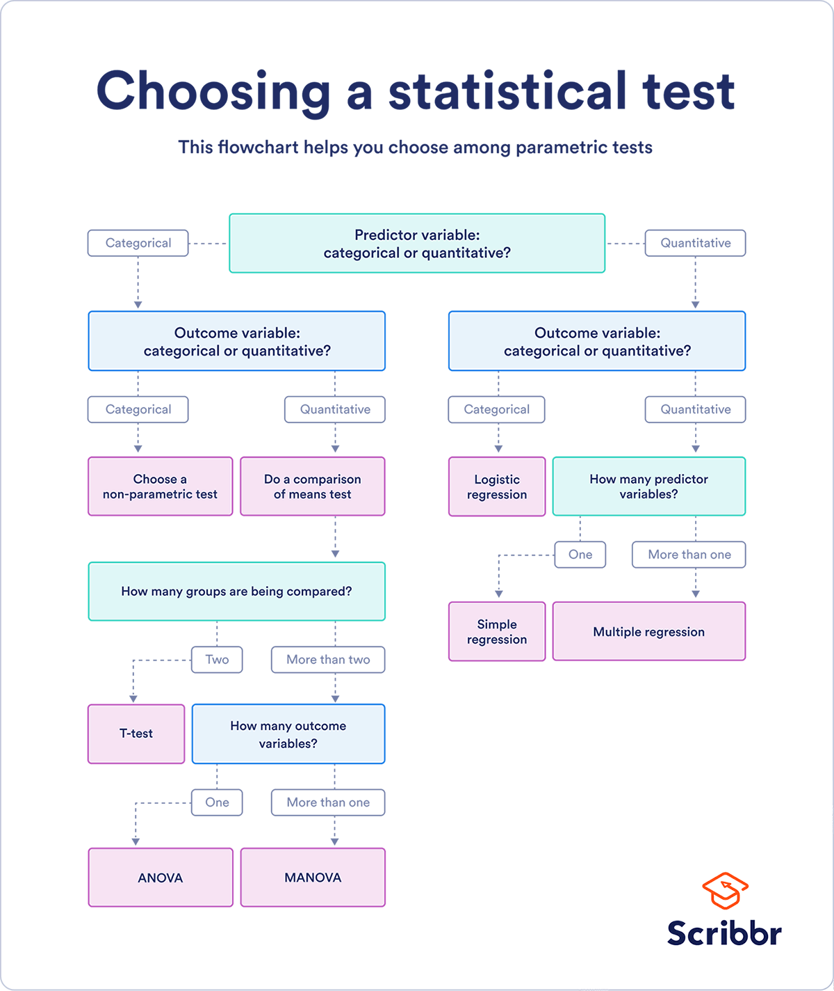](https://cdn.scribbr.com/wp-content/uploads/2020/01/flowchart-for-choosing-a-statistical-test.png)

### 2. 1. Alternative Hypothesis and Null Hypothesis

In hypothesis testing, the hypothesis that’s being tested is known as the **alternative hypothesis**. Often, it’s expressed as a correlation or statistical relationship between variables. The **null hypothesis**, on the other hand, is a statement that’s meant to show there’s no statistical relationship between variables being tested. It’s typically the exact opposite of whatever is stated in the alternative hypothesis.

For example, consider a company’s leadership team who historically and reliably sees $12 million in monthly revenue. They want to understand if reducing the price of their services will attract more customers and, in turn, increase revenue.

In this case, the alternative hypothesis may take the form of a statement such as: “If we reduce the price of our flagship service by five percent, then we’ll see an increase in sales and realize revenues greater than $12 million in the next month.”

The null hypothesis, on the other hand, would indicate that revenues wouldn’t increase from the base of $12 million, or might even decrease.

## A Business Example

Hypothesis testing has many business applications. Let's take quality control for example. Say Widgets R Us is manufacturing a widget that must have a width of 150 mm, with a small tolerance. In this case the basic hypotheses might be:

H0: The widget sizes equal 150  
HA: The widget sizes do not equal 150.

For the statistics used in the test, Widgets R Us will randomly sample and measure the average widget size over 30 production runs. They want a fairly strict assurance that the samples are close to the required value, so they use a 5% (0.05) significance level for evaluation.

They measure the average of the samples and their standard deviation. As we expect, the sample values will be normally distributed about the average, so we can also derive the Z-statistic for the data. This value reflects the number of standard deviations the measured value is from the average.

Assume we derived the following values from our test:

Average = 150.12  
Standard Deviation = 0.496  
Z-statistic = 1.23

The Z-statistic of 1.23 falls well within the 0.05 value significance level, which occurs at 2.576 standard deviations. Widgets R Us can say that the result is not statistically significant at the 5% probability value, in other words, the measured value is relatively likely to occur as a matter of chance. However it is stated, if the value falls inside the range, the null hypothesis can be accepted.

### To Plan the Marketing Strategies

Many businesses often use hypothesis testing to determine the impact of the newly implemented marketing techniques, campaigns or other tactics on the sales of the product. For example, the marketing department of the company assumed that if they spend more the digital advertisements it would lead to a rise in sales. To verify this assumption, the marketing department may raise the digital advertisement budget for a particular period, and then analyse the collected data at the end of that period. They have to perform hypothesis testing to verify their assumption. Here,

**Null Hypothesis (Ho)**: The average sales are the same before and after the rise in the digital advertisement budget, i.e., μafter = μbefore

**Alternative Hypothesis (Ha)**: The average sales increase after the rise in the digital advertisement budget, i.e., μafter > μbefore

If the P-value is smaller than the significant value (say .05), then the null hypothesis can be rejected by the marketing department, and they can conclude that the rise in the digital advertisement budget can result in a rise in the sales of the product.